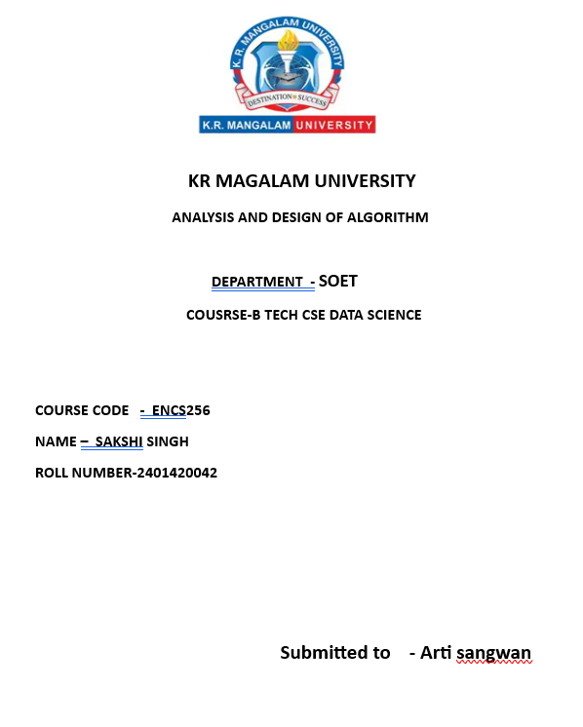

Assignmmen 3
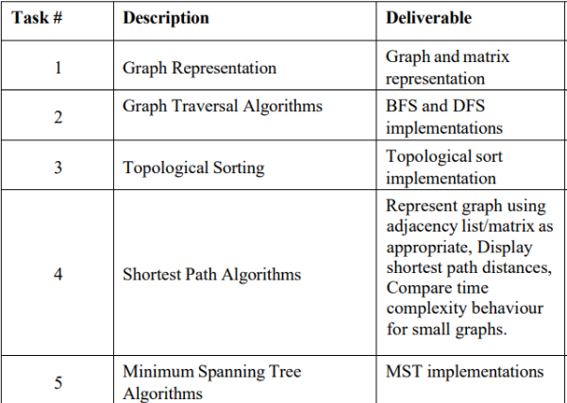

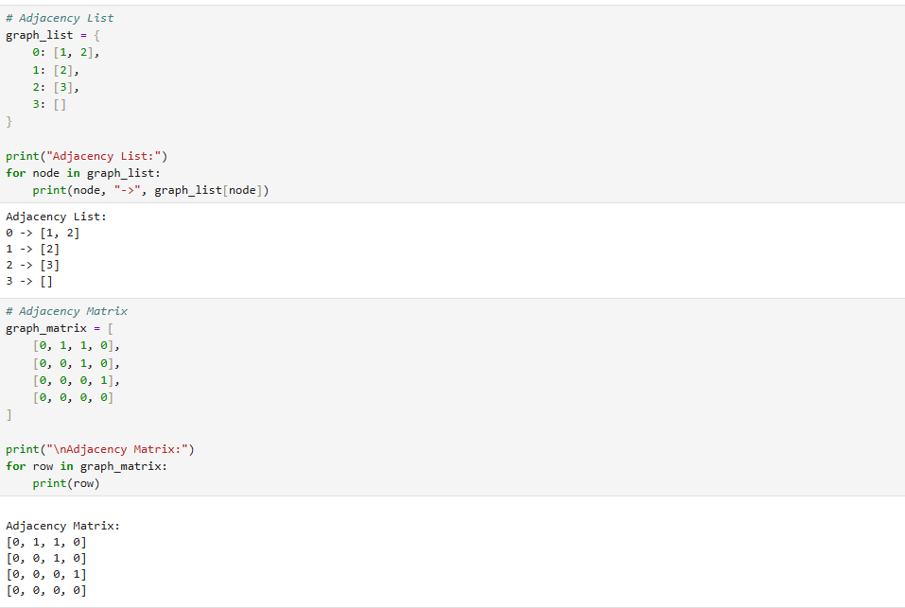

2. Graph Traversal Algorithms (BFS and DFS)
In this task, I implemented two graph traversal techniques: Breadth-First Search (BFS) and Depth-First Search (DFS). BFS explores the graph level by level using a queue, visiting all neighboring nodes before moving deeper. DFS explores as deep as possible before backtracking, using recursion or a stack. These algorithms are useful for searching nodes, checking connectivity, and exploring graph structures.

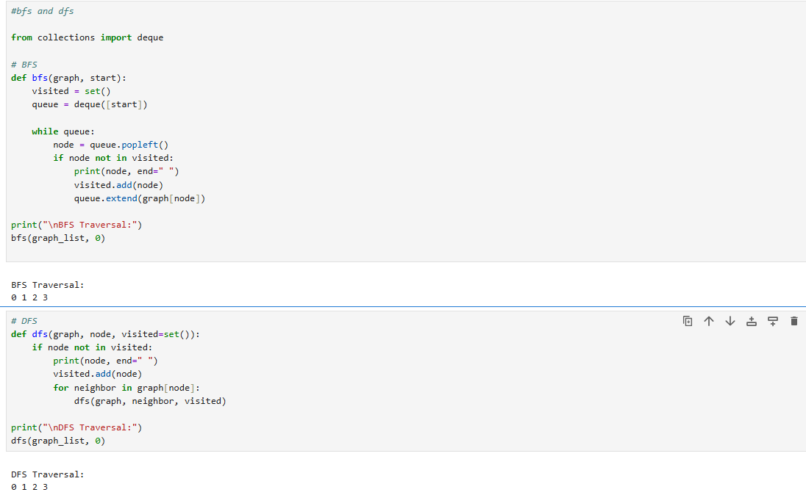

4. Shortest Path Algorithms
In this task, I implemented algorithms to find the shortest path between nodes in a graph. The graph was represented using adjacency list or matrix. I calculated the shortest distance from a source node to all other nodes using Dijkstra’s algorithm for graphs with non-negative edge weights. I also observed the time complexity and performance for small graphs.

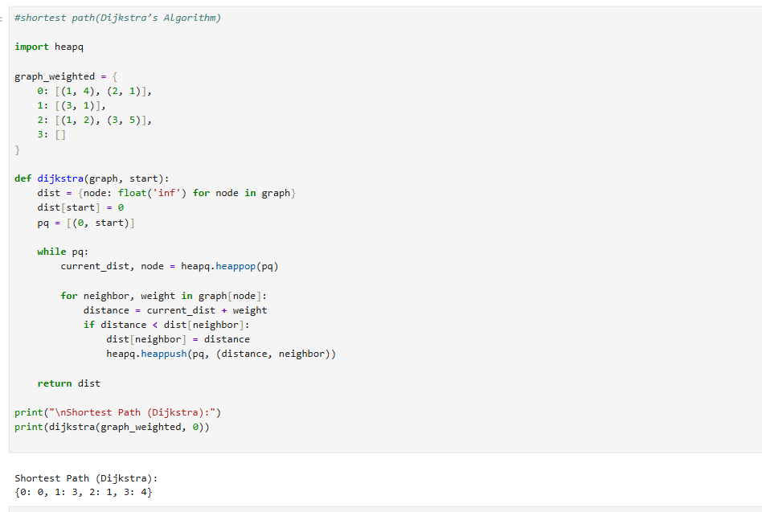

5. Minimum Spanning Tree (MST) Algorithms
In this task, I implemented Minimum Spanning Tree algorithms to connect all vertices in a graph with the minimum total edge weight and without forming cycles. I used Prim’s algorithm and Kruskal’s algorithm to generate the MST. These algorithms are useful in network design and optimization problems.
